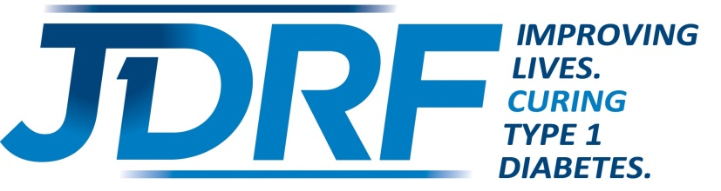

2018 Ambassador Application
JDRF One Walk and Ride to Cure Diabetes

Name: ____________________________________________________________________________________

Date of Birth: ________________________________ Age at Diagnosis: _______________________________

Parent(s) Name (if under 18): __________________________________________________________________

Mailing Address: ____________________________________________________________________________

City: ____________________________________ State: ____________________ Zip: ____________________

Preferred Phone #:______________________________ ____________________________________________

Email Address: _____________________________________________________________________________

School/Employer: ______________________________ Grade/Title: __________________________________

Emergency Contact: ____________________________ Phone #:_____________________________________

Tell us about your involvement with JDRF (walk, ride, gala, or outreach events).

How has JDRF helped you in living with type 1 diabetes (T1D)?

What methods do you use to manage your T1D (pump, CGM, multiple daily injections)? How long have you used them?

What has been your most successful fundraiser or how do you plan to fundraise?

