June 11, 2018
Muirfield Village
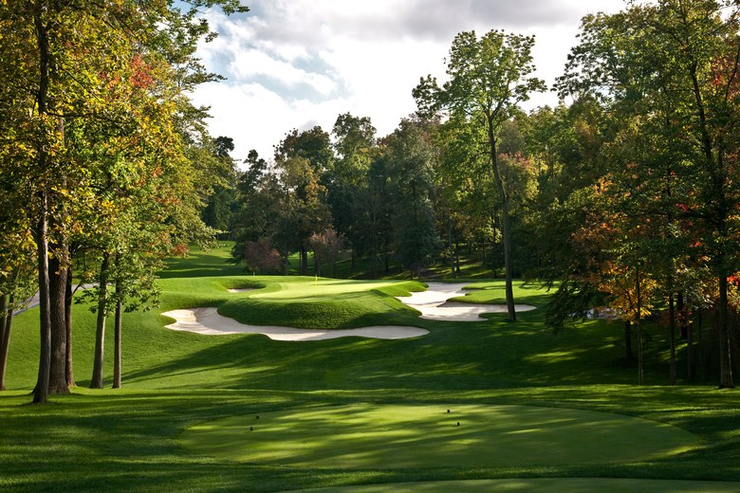
Imagine yourself being whisked away by private jet for JDRF’s 8th Annual Fly Away Dream Golf to play one of the most exclusive golf courses in the country. Muirfield Village Golf Club, designed by Jack Nicklaus and considered to be his masterpiece, is located in Dublin, Ohio. It is the annual site of the Memorial Tournament on the PGA Tour. Muirfield Village is the only course to host the Ryder Cup, Presidents Cup and Solheim Cup, the three professional team cups involving Team USA squads. This course is currently ranked 1st in the state of Ohio, 15th out of America’s 100 Greatest Golf Courses and one of the top 50 in the world.

We hope you will join us for this spectacular day of golf and be part of the “Muirfield Village Experience”

Event registration opens March 2018. Details to follow.

