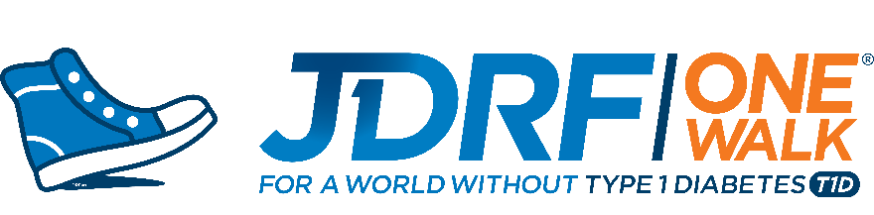
SAMPLE FUNDRAISING EMAIL MESSAGES

From Walker/Team Captain to Donor (T1D Connection)
Hi [FIRST NAME],
I hope you are doing well and staying safe and healthy during this crazy time! I'm sure you’ve been hearing all over the news that “only the vulnerable will be at risk”. Did you know that those living with T1D, like [CONNECTION], are at greater risk? While living with T1D doesn’t make you more suspectable to COVID-19, just like the flu, the complications you may develop can be life threatening. That is why now, more than ever, we have to continue to support one another. Not only through social distancing, but by continuing to fund the research that is leading the fight against T1D.
I know this feels like an awkward time to be asking for donations but no matter what is happening in the world, type 1 diabetes doesn’t go away. And as long as T1D is here, I will be here advocating and fundraising until this disease no longer exists.
No donation is too small. Every dollar you can give will truly make a difference.
Here is the link: INSERT LINK
Thank you!

From Walker/Team Captain to Donor (General)
Hi [FISRT NAME],
There are a million heartbreaks out there right now. Usually, this would be my annual letter inviting you to take part in one of our most hopeful and joyful days of the year: JDRF’s One Walk. Of course, the Walk in [INSERT LOCATION] is called off. But I want to share some fun things we are doing that intertwine learning, fun and curing type 1 – and let you know that you can be part of them from your own self-distancing locale too!
We will be [INSERT VIRTUAL PLAN]. I’d love to ask you to follow Facebook @JDRFAZ or Instagram jdrf_az to see what fun things we create and share, and, in any way you can in this difficult time, support us with a donation.
No donation is too small. I mean that! Every dollar you can give will truly make a difference.
Here is the link: INSERT LINK
Thank you!

From Team Captain to Team
Hi [TEAM NAME],
First and foremost, I hope all of you are doing what you can to protect yourself, your family and your friends. I know there is a lot of uncertainty, and honestly, it’s pretty scary! But I want you to remember, we’re not just a team on Walk Day. We’re some of each other’s biggest supporters. And while we may be social distancing for a while, that’ doesn’t mean we can’t get together virtually!
Why don’t we meet up on [GOOGLE HANGOUTS, ZOOM, FACETIME, ETC.] one night this week and reimagine our Walk Day experience together? I can share with you what our JDRF Chapter is planning on Facebook and some different ways our team can get involved. I also have some fun ideas for fundraisers we can do virtually while we’re all social distancing that can help us reach our team goal!
I know it may feel awkward to ask for donations when so much is going on, but T1D doesn’t slow down no matter what’s going on and that’s why we can’t either.
We as a community rise to challenges, and there is no better time than now to show that we are truly stronger together. Stay smart. Stay safe. Stay healthy. And I look forward to seeing you soon, virtually!
From Walker to Donor
To [TEAM NAME] Supporters:
Please pardon this interruption during these stressful and trying times. I was debating whether to send this email, given the current environment, but I ultimately decided to because Type 1 Diabetes (T1D) unfortunately does not stop for anything, including recessions or pandemics. And, in fact, during such times, T1D treatment and management becomes even more difficult for many families because of insulin availability/cost and loss of income. It is with those families in mind that I gently ask you to consider donating again to my family Walk team – [INSERT TEAM NAME] – which raises funds to find a cure for this unrelenting disease. I started [TEAM NAME] after my [CONNECTION] was diagnosed with T1D in [DATE], and because of generous donors like you, we have raised approximately $[TOTAL RAISED] over the past # of years. This year’s Walk will be virtual because of the coronavirus pandemic, which makes online donations even more critical. If you can’t donate, I completely understand and thank you again, from the bottom of my heart, for your past support and wish you and your family all the best in 2020 and beyond.
Here is the link: INSERT TEAM LINK
With gratitude,
From Walker/Team Captain to Donor

I was debating whether to send this email (post this message) given the current health crisis, its loss of life, of everyday activity, and of financial resources, but I ultimately decided to go ahead. Because Type 1 Diabetes (T1D,) unfortunately, does not stop for anything, including recessions or pandemics. And, in fact, during such times, T1D treatment and management becomes even more difficult for many families during these times because of a compromised immune system, or the high cost of insulin and loss of income. It is with those families in mind, that I gently ask you to consider donating to my (INSERT TEAM NAME) which raises funds for research to find a cure for this unrelenting disease. I walk because/for__________________________________________________.

This year’s Walk will be virtual due to the coronavirus pandemic, which makes online donations even more critical. I am grateful for your support and understand if this isn’t a good time. Wishing you and your family all the best in 2020 and beyond. Stay healthy and safe. We’re Stronger Together!

Thank you,
INSERT TEAM LINK

