Type 1 Diabetes Family Meet & Greet
Who is invited: Children of all ages with type 1 diabetes and their family members/friends

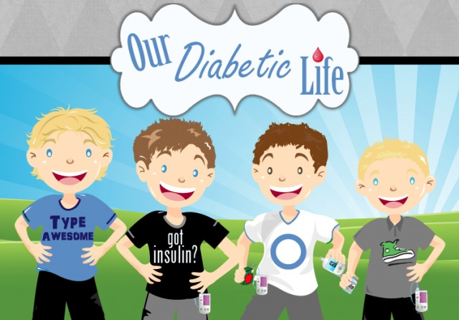
1468 Madison Ave, Annenberg building, 4th floor
Pediatric Endocrinology & Diabetes Clinic Lobby
Date: Thursday October 11th
Time: 5:30pm-6:30pm
Light refreshments will be provided

We will be giving an update on the newest type 1 diabetes technology and research innovations!
RSVP to Anna Aluf or Taylor Murphy
Anna.aluf@mountsinai.org; Taylor.murphy@mountsinai.org

